Lecture 1: XML Introduction
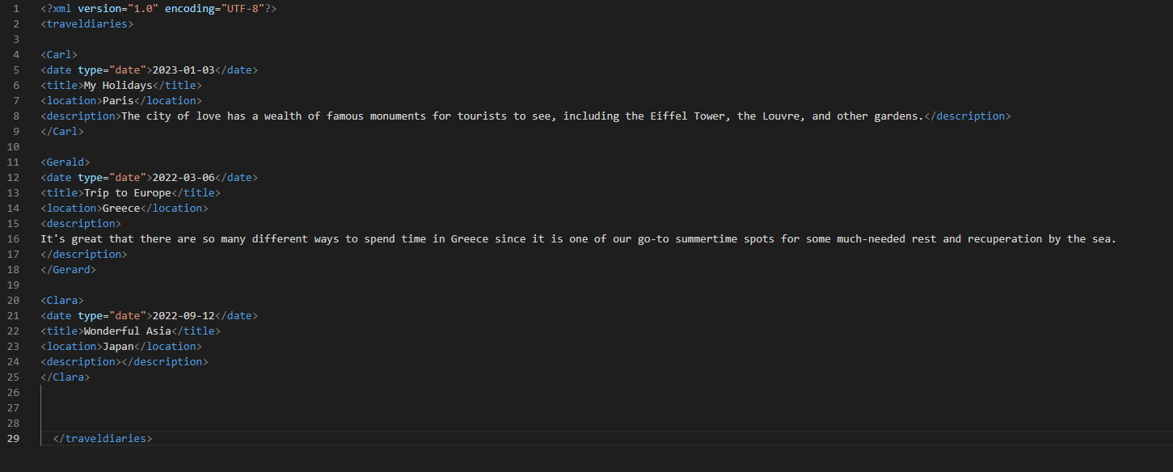
This XML document is an example of a travel diary, where different travelers (Carl, Gerard, and Clara) have documented their experiences and adventures in various locations around the world.
It has a root element <traveldiaries> which contains multiple elements <Carl>, <Gerard>, and <Clara>. Each of these elements represents the travel diary of a different traveler and contains sub-elements such as <date>, <title>, <location>, and <description> that describe the travel experience. The <date> element contains an attribute type="date" to specify the data type as date. The contents of the <description> element provide more detailed information about the traveler's experience.

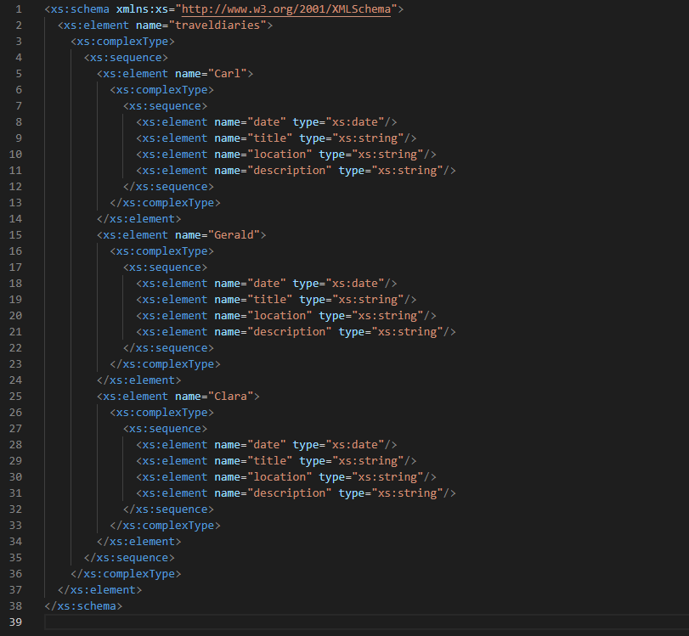

This XML schema defines the structure and data types for the "traveldiaries" XML document. The root element "traveldiaries" has a complex type, which includes a sequence of "Carl", "Gerald", and "Clara" elements. Each of these elements also has a complex type, which includes a sequence of "date", "title", "location", and "description" elements. The data type of each of these elements is specified as “xs:date”, “xs:string”, respectively.

